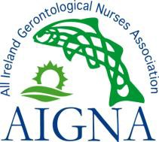
All Ireland Gerontological Nurses Association (AIGNA) Corporate Membership Application Form

AIGNA’s Membership represents nurses from a variety of clinical settings, from community to residential care, public and private, clinical practice to education, management & research. AIGNA events are open to all health care workers or anyone with an interest in older people. AIGNA Corporate Membership for Directors of Nursing/Person in Charge that want the flexibility of sending any 4 members of staff (including nursing, allied health professionals, ancillary staff) to both the AIGNA Annual Conference and Annual Master Class. For an annual fee of €350, this represents excellent value for money. In addition to the benefits of AIGNA membership, a prestigious certificate of AIGNA Corporate Membership will be provided for display in your facility.

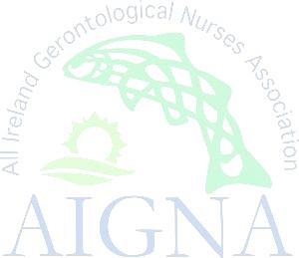  Full Names of Staff:  (Registered as AIGNA Members, but other staff may attend AIGNA events) | First Name: | Last Name: | Designation & PIN No if R/N | Contact E Mail Address:
 | 1.
 | 2.
 | 3.
 | 4.
Work Address: | Postcode/EirCode:
Work Contact Details: | Tel:  E Mail: |  | Director of Nursing/Person in Charge Details:  Name:_______________________________________  Tel: _____________________________________  E Mail:___________________________________
Membership runs from 1st April (Year of application) to 31st March (the following year). Option: Corporate Membership 1 Year: Fee €350
Method of Payment: Cheque/Postal Order/Bank Draft/Standing Order. Please forward completed application forms with payment to: AIGNA, PO Box 12706, Dublin 15. Remember you can now set up a Standing Order with your own bank for Automatic Renewal of your AIGNA Membership.
Account Name: All Ireland Gerontological Nurses Association. IBAN: IE26 AIBK 9343 4844 0580 56 BIC: AIBKIE2D
Phone: +353 (0) 85 764 3833. (Voice mail) @AIGNA_info Web: www.aigna.ie E-mail: aignainfo@gmail.com
https://www.facebook.com/pages/All-Ireland-Gerontological-Nurses-Association- AIGNA/183651295015842

